**Embodiment Design Report**

***Subsea ROV***

**Prepared For**

**Mr. William Ledbetter**

**Mr. Don Wells**



Presented to

Instructors: Dr. Andrew Conkey

Oscar Lopez, MSCE, P.E., Professor of Practice

Sponsor: Mr. William Ledbetter

Mr. Don Wells

Prepared by: Ocean Gig

Eric Bauman

Bobby Clukey

Heath Garrett

Marcus Navas

David Scott

Texas A&M University

Department of Multidisciplinary Engineering

ITDE 401 Interdisciplinary Design

FALL 2024 – Sections 900/M02

November 22, 2024

# Executive Summary

Summarize the project for the semester within two pages (ideally, one page). This includes the design steps taken to reach your final point in the project. Essentially, you need to address:

* What was the need
* What are the top-level functions and specifications
* What was finally opted for
* Future goal of team regarding the project
* Note of thanks to the sponsors

Whenever divers work underwater, they put themselves at risk of injury and death. Because of this, divers are only able to safely work at about 100 meters, and most deepsea infrastructure is much deeper than that. There is a need to replace these divers to take them out of the risky scenarios while maintaining the capabilities of a human diver. The current models of subsea ROVs are big, expensive, and unmaneuverable. To make an ROV similar to that of a human diver, it must be smaller, able to fit in the same size holes and areas that a diver can, and be able to swim like a diver could underwater.

A special thanks goes to Mr. William Ledbetter and Mr. Don Wells for their generous support in helping the team with their work in working on the project. Thanks also must be given to the members of Oceaneering International, Inc. for their willingness to talk with the team about subsea ROVs and their experiences in the industry.

**Embodiment Design Report**

**Table of Contents**

**Executive Summary 1**

**List of Figures and Tables 3**

**Glossary 4**

**-Introduction 1**

-Need Statement and Analysis 2

-Quality Functional Diagram (QFD) 3

-Background and Design Research 6

-Function Structure 8

-Design Specifications Table 9

-Overall Expected System Description 12

**-Concept Generation and Analysis: 14**

**Design Embodiment 17**

**-**System Description 17

-Human Factor Engineering 17

-Engineering Analysis 17

-Failure Mode and Effect Analysis 18

-Cost Estimation 18

-Work Breakdown Structure Semester II 19

**Summary 23**

A. List of Abbreviations 24

B. References 24

C. Order of Magnitude and Detailed Calculations/Analysis 24

D. Concepts Entertained. 25

E. Down Select 25

F. Detailed working drawings/models/assembly 25

G: Cost Estimation Details 25

**{ The intent of this report is for the design team to present the application of the top down design methodology to this course to their specific project.**

**All sections need to have an introductory paragraph the maps out what that section covers.**

**Note content in this report is parallel to has been asked for through the term. However, teams are encouraged to reevaluate what was put into that report before blindly copying and pasting into this report.**

**NOTE: Remove the bold text in the {} from your submitted report}**

# List of Figures and Tables

The list is to be broken up into two sections. One for figures and one for tables. Can use the “auto” generate feature in Word (can be tricky to use). Be sure that figure no. and page no. match.

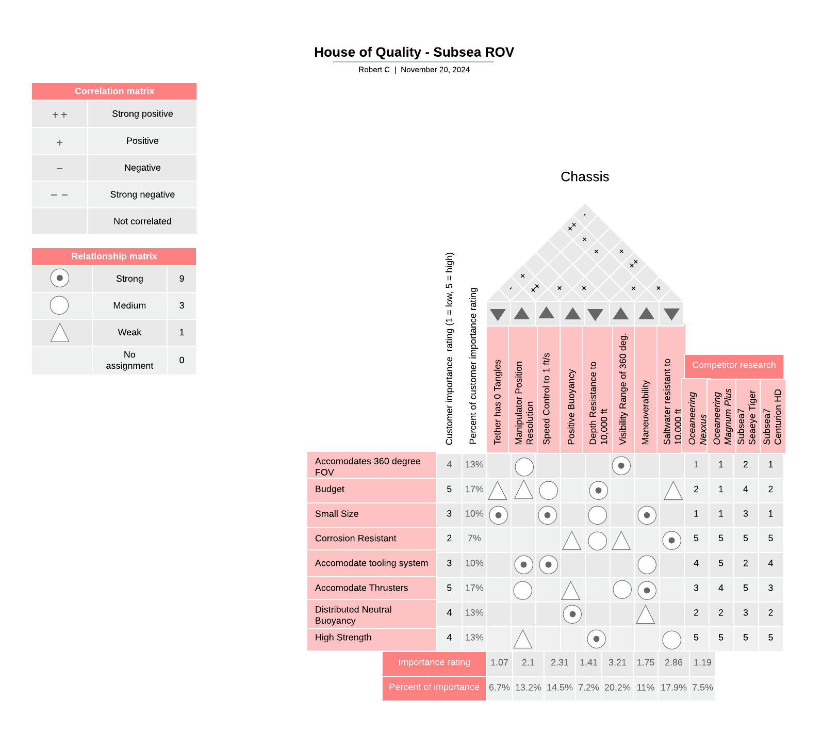

**Figure 1.** Chassis subsystem House of Quality

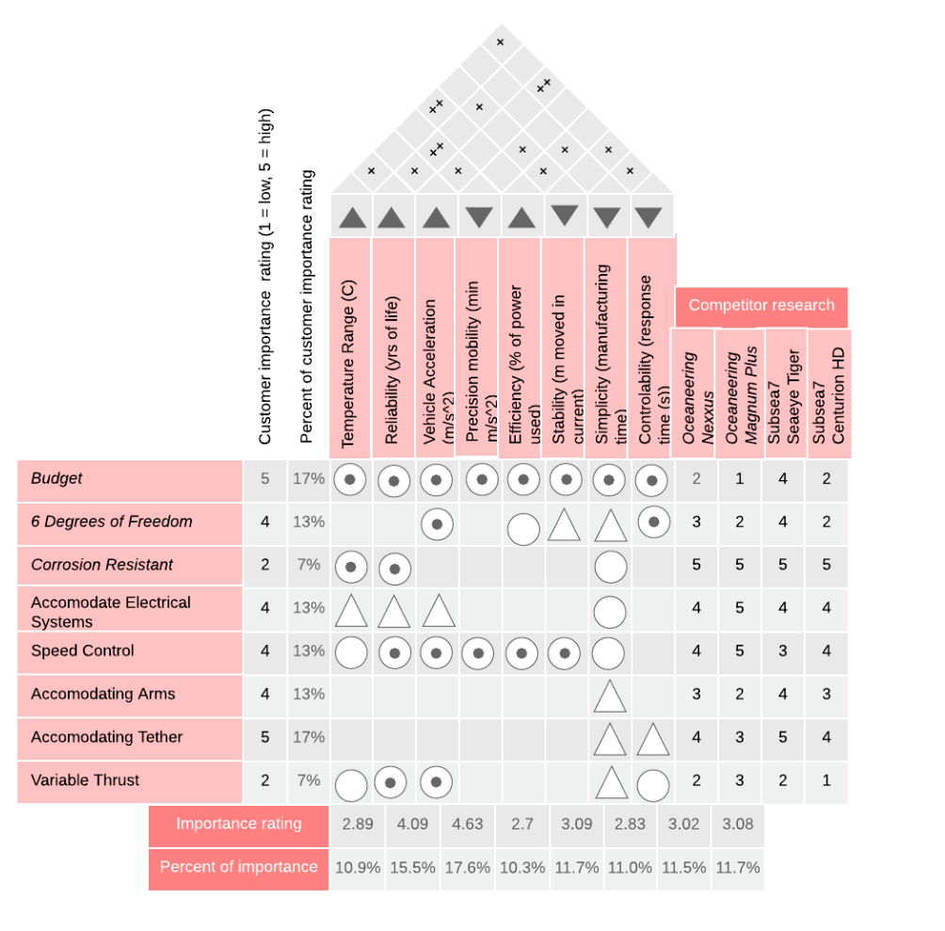

**Figure 2.** Propulsion subsystem House of Quality

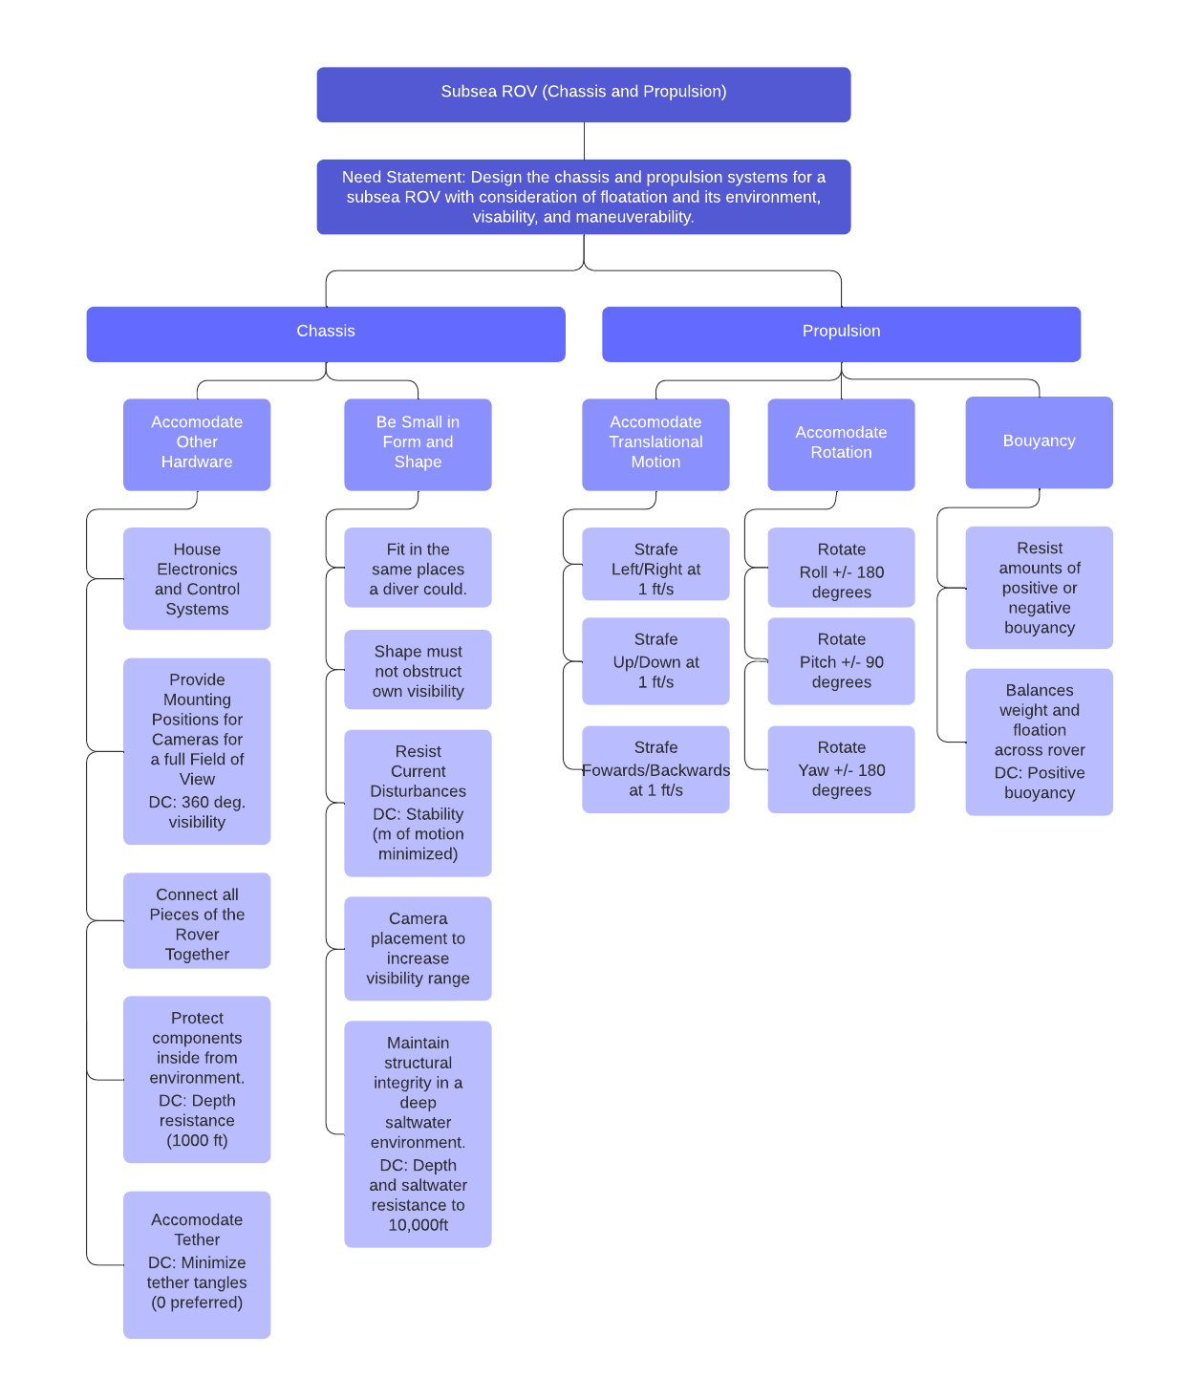

**Figure 3.** Primary Function Structure

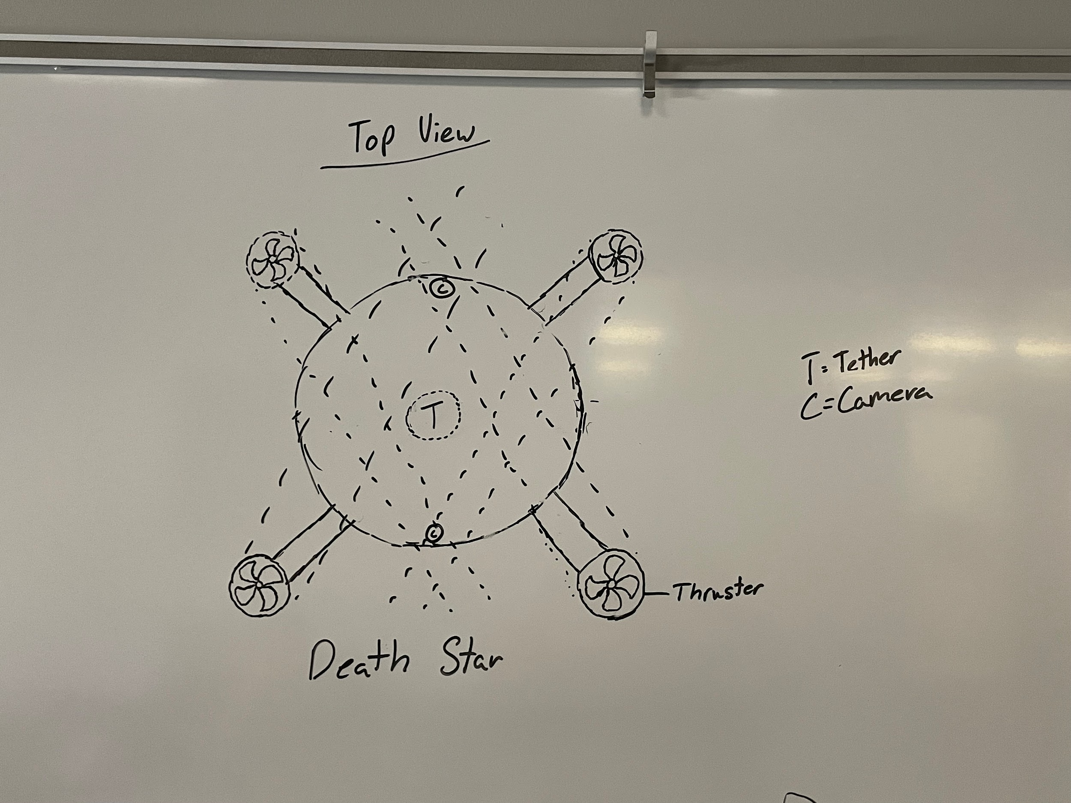

**Figure 4.** The “Death Star” design

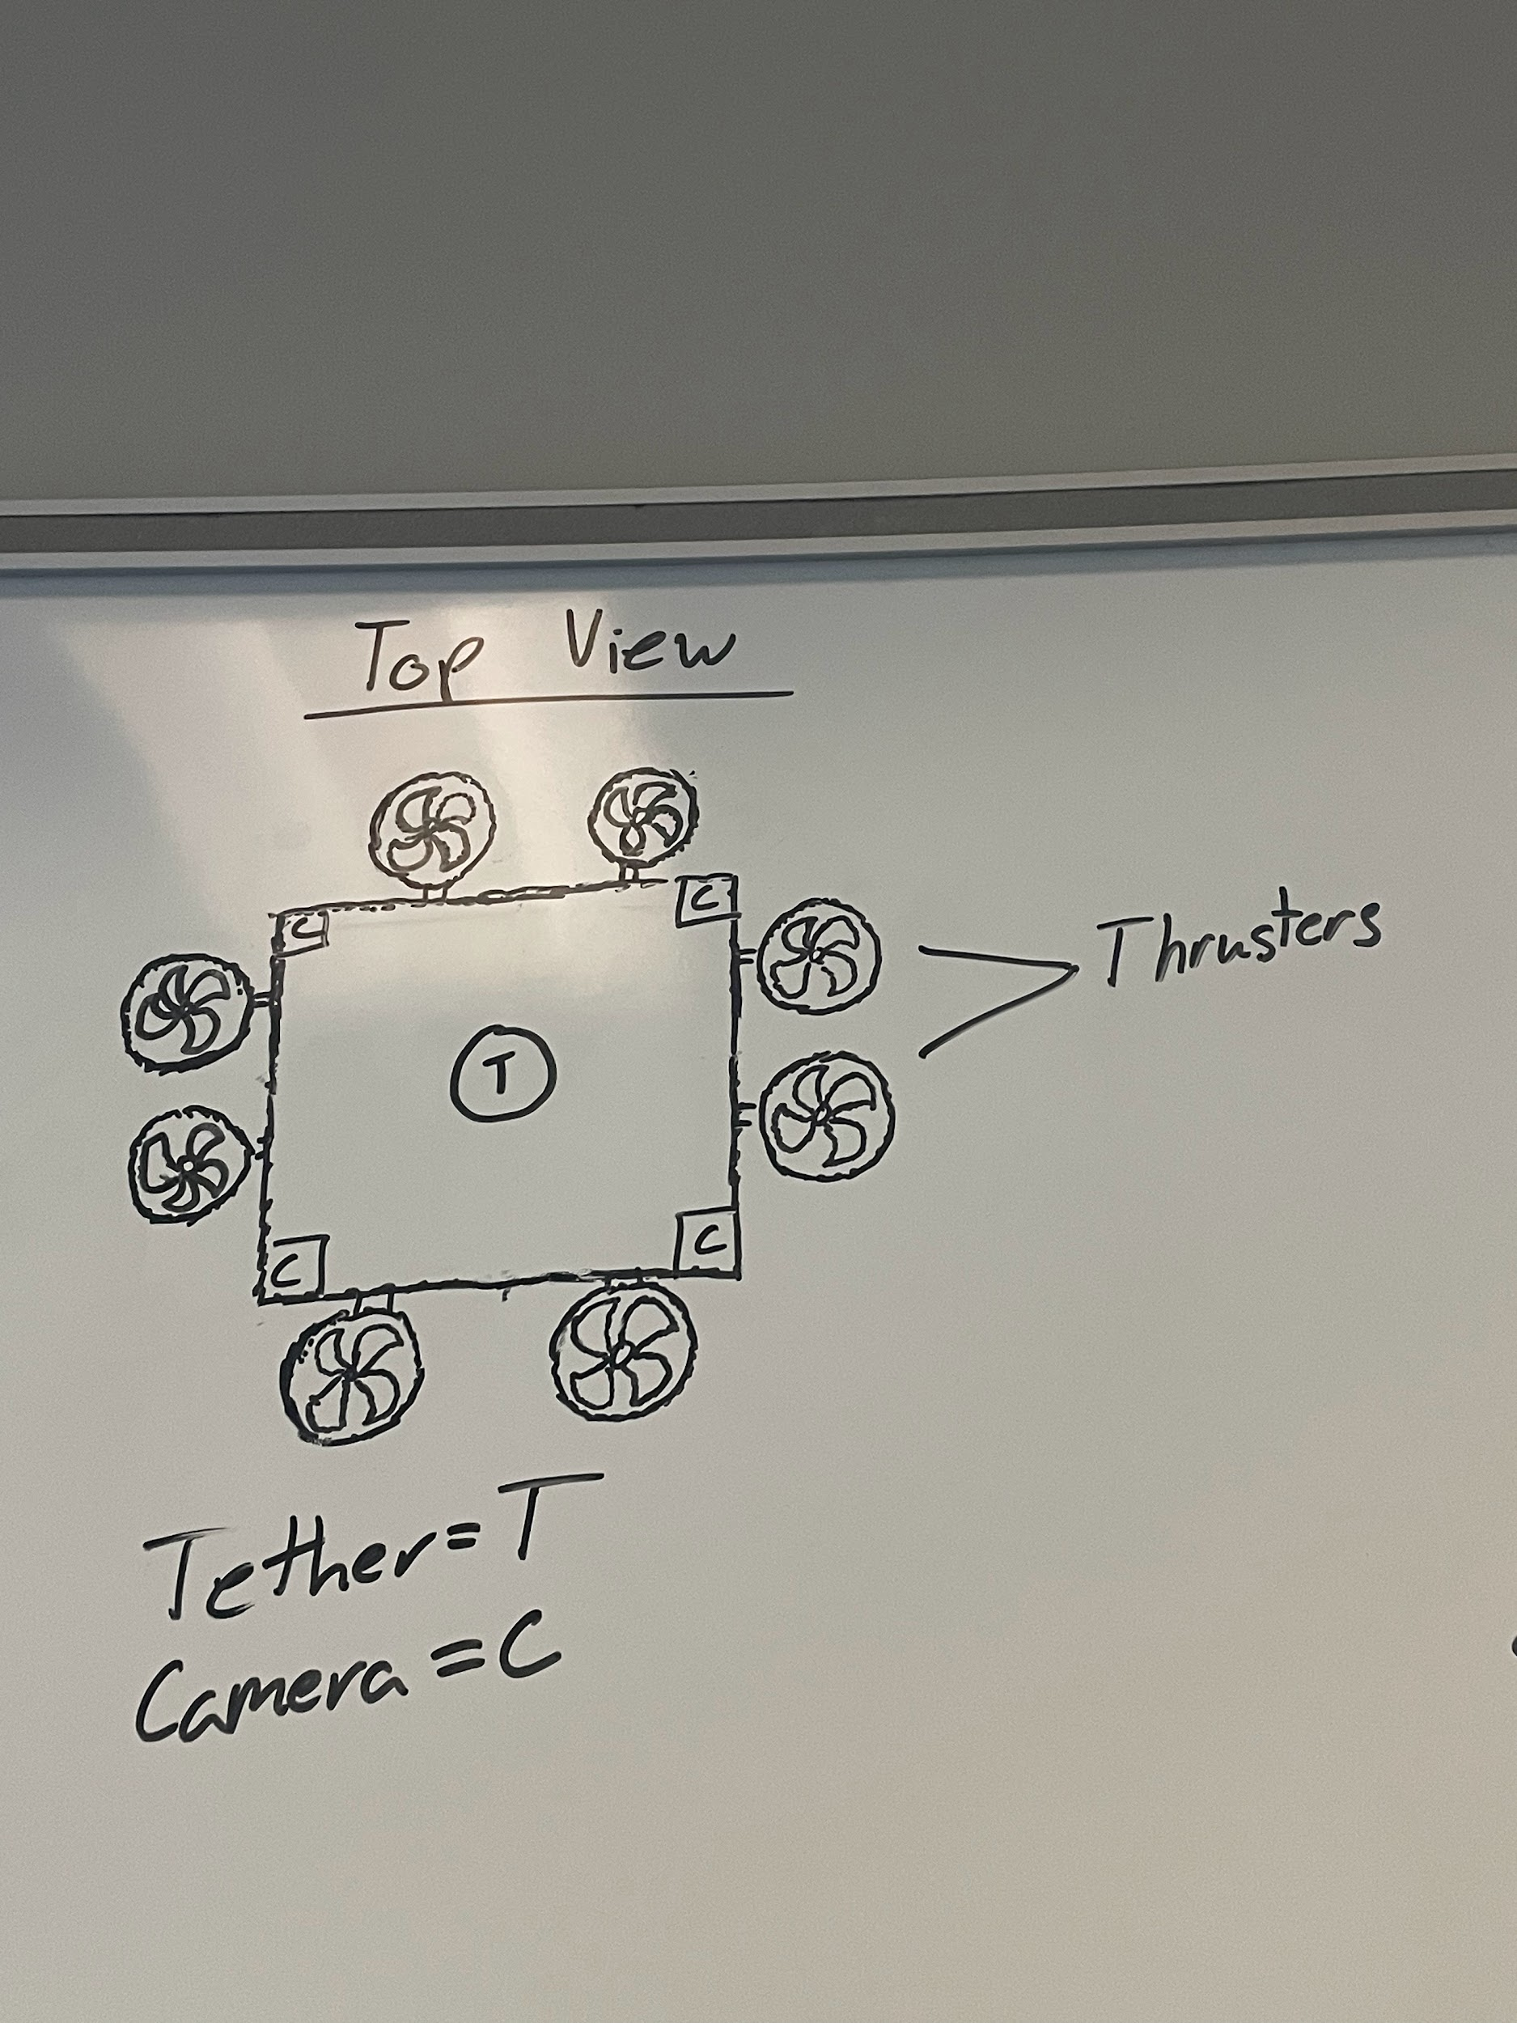

**Figure 5.** The “Box” design

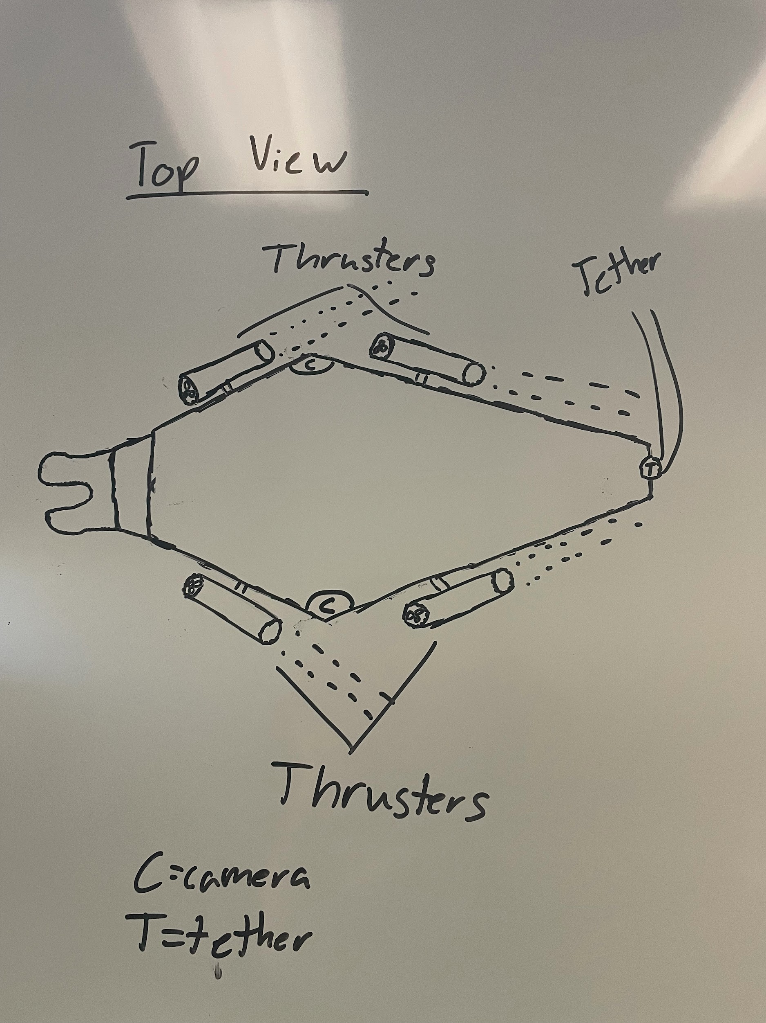

**Figure 6.** The “Turkey” design

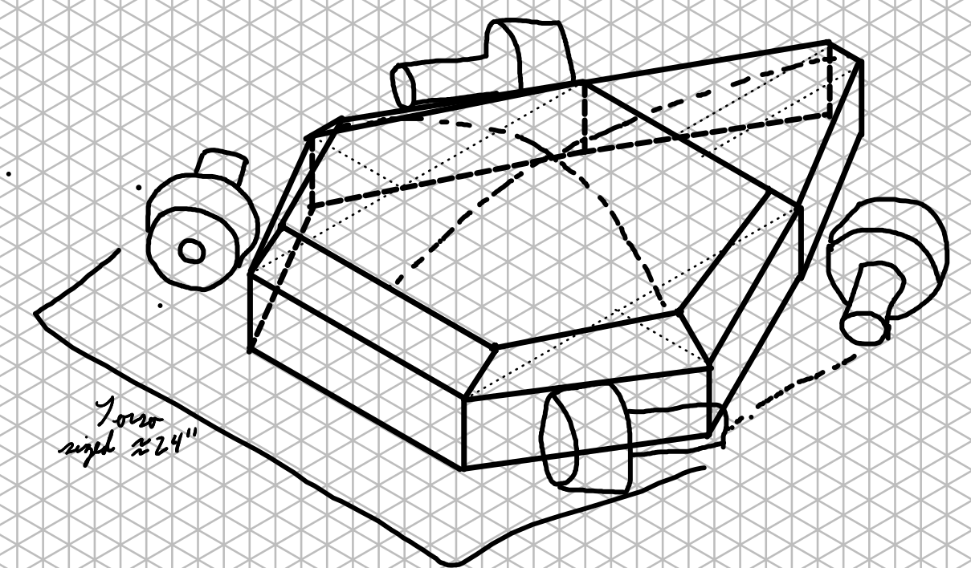

**Figure 7.** Isometric drawing of The Turkey design. The design will be 24 inches long, 25 inches wide, and 10 inches tall.

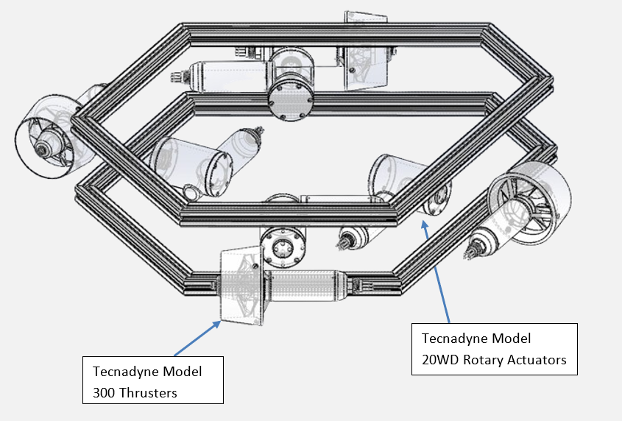

**Figure 8.** The CAD drawing with the Tecnadyne Model 300 thrusters and Tecnadyne Model 20WD rotary actuators labeled.

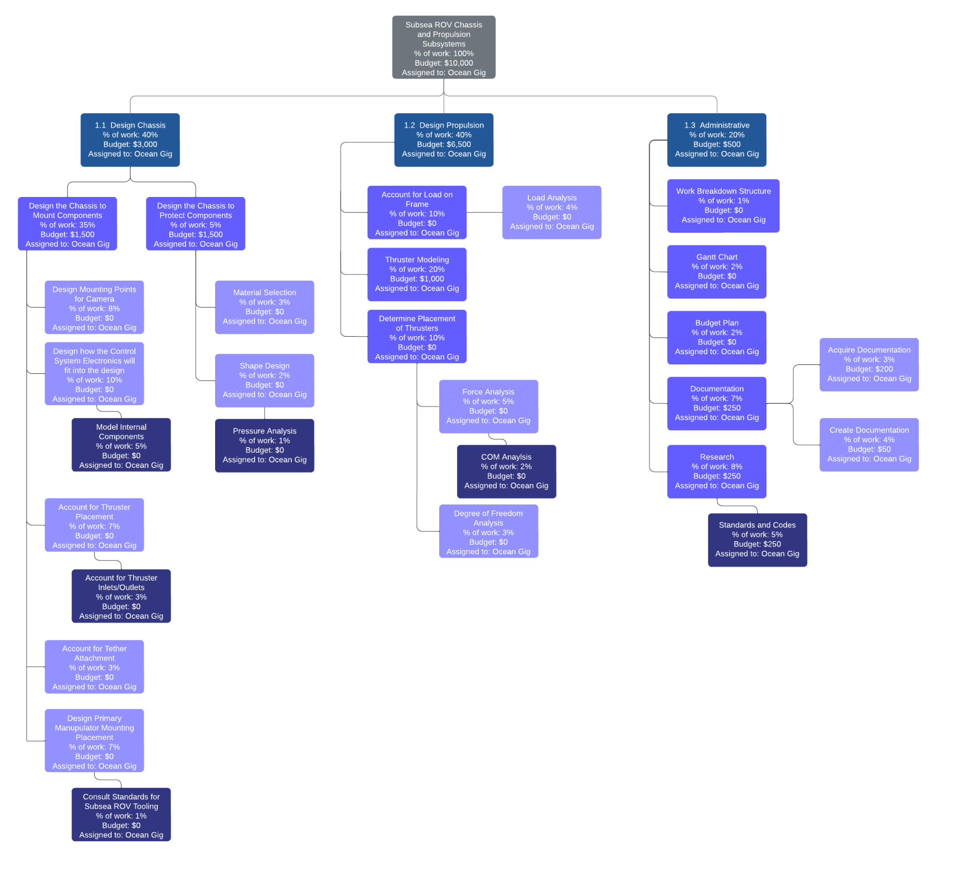

**Figure 9.** The Work Breakdown Structure for the project

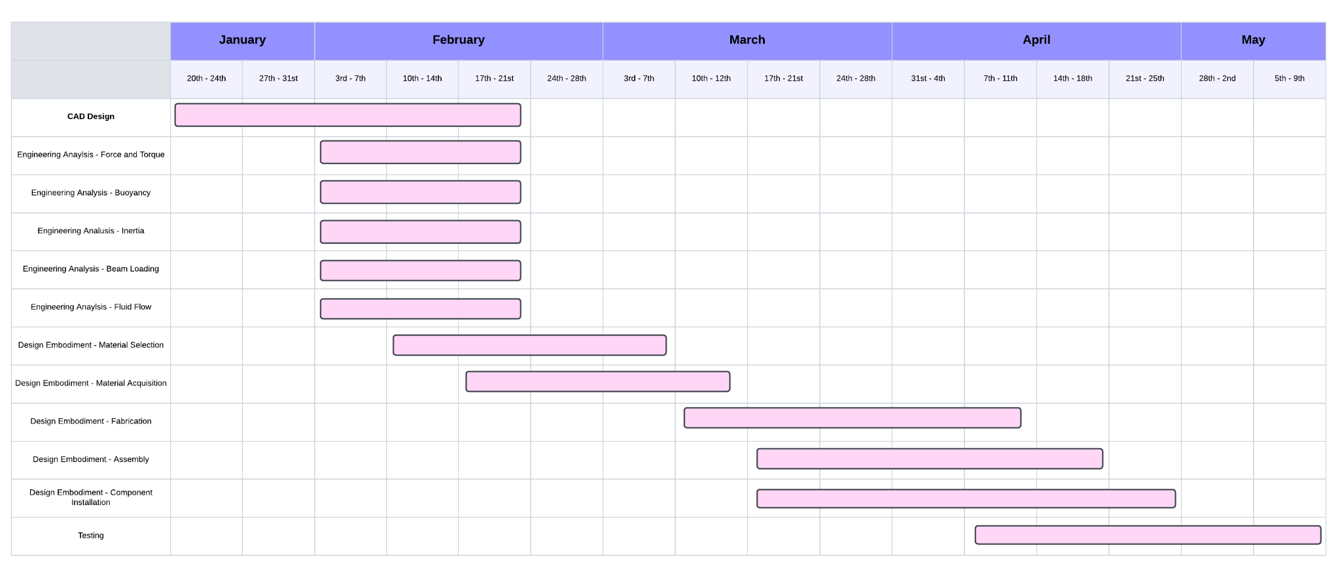

**Figure 10.** Gantt Chart for the spring 2025 semester

**Table 1.** Researched Patents and Trademarks

| **Patent Document ID** | **Patent Holder** | **Publication Date** | **Patent Name** |
| --- | --- | --- | --- |
| US 20240101236 A1 | Oceaneering International, Inc. | 2024-03-28 | MODULAR SUBSEA VEHICLE |
| US 20240383591 A1 | Heliopolis Holdings Limited | 2024-11-21 | UNDERWATER DOCKING STATION |
| US 20240239457 A1 | Taylor; Shawn  Cutri; Alex  Nguyen; Khang  Yousif; Sarmad  Le; Thanh | 2024-07-18 | AN UNDERWATER PROBE OR SUBMERSIBLE |
| US 20240218761 A1 | TLA SUBSEA LTD | 2024-07-04 | APPARATUS, SYSTEM AND METHOD FOR TETHERING A SUBSEA ASSEMBLY |

**Table 2.** Researched Standards, Codes, and Regulations

| **Code ID** | **Code Name** |
| --- | --- |
| IMCA D014 | IMCA international code of practice for offshore diving |
| IMCA D049 | Code of practice for the use of high pressure jetting equipment by divers |
| IMCA D045/R015 | Code of practice for the safe use of electricity under water |
| IMCA R004 | The safe and efficient operation of remotely operated vehicles |
| IMCA D054/R020 | Remotely operated vehicle intervention during diving operations |
| IMCA R009 | ROV mobilisation |
| API RP 17A | Design and Operation of Subsea Production Systems |
| API RP 17H | Remotely Operated Tools and Interfaces on Subsea Production Systems |
| API RP 17P | Recommended Practice for Subsea Structures and Manifolds |
| API RP 17V | Recommended Practice for Analysis, Design, Installation, and Testing of Safety Systems for Subsea Applications |

**Table 3.** Design Requirements and Specifications

| Function | Action | Parameter/ Constraints | Analysis Type  (Engineering Science) | Comments |
| --- | --- | --- | --- | --- |
| 1.0 | Develop unique chassis | Reduce size to access tight spots | Structural Analysis, CAD design, fluid dynamics, budgeting | Keep material selection in mind. |
| 1.1 | Accommodate a previously designed visibility system | 360 degree, <100ms latency | Electronics interfacing, energy management, data rate, processor speed | Focus more on visibility, and its respect to physical systems. |
| 1.2 | Utilize tooling and a manipulator | Receive accessories, operator-friendly interfacing | CAD modeling, material analysis, | Research standardized tools and tasks, and keep mounting consideration in design |
| 1.3 | Utilize materials that provide strength and structure | Maintain positive buoyancy and remain strong at depth | Materials analysis, fabrication, | Should withstand 10,000 ft of depth |
| 2.0 | Equip chassis with efficient propulsion system | Provide 6 degrees of freedom | CAD design, fluid dynamics, Electronics, Energy management | It should be able to move in each direction independently. |
| 2.1 | Integrate 180 degree actuators | Mounted thrusters to rotate 360 degrees | Electronics, control systems, fluid dynamics | Ensure safety mechanisms to protect wiring. |
| 2.2 | Efficiently balance changes in mass | <0.1 second reaction to changes in load between 4 active thrusters | Fluid dynamics, motion control | Incorporate redundancy in case of thruster failure as well |
| 2.3 | Efficiently manage tether | Protect tether; prevent exploration inhibition | Electronics, control systems, fabrication, CAD modeling | Consider improving tether visibility through reflectors or colors. |

# 

**Table 4.** Our Decision Matrix for each design

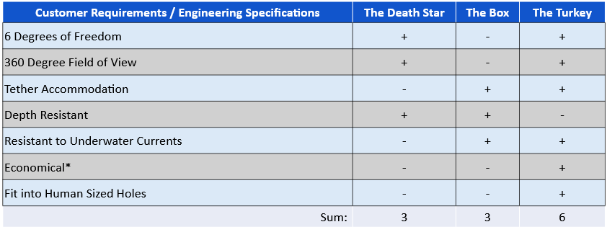

# 

**Table 5.** The Risk Priority Number calculations for our Failure Mode and Effect Analysis

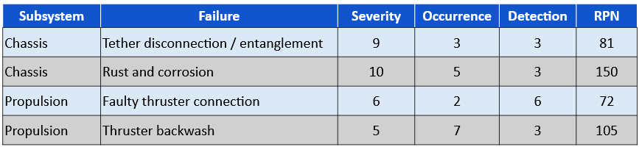

**Table 6.** The cost estimation for the project, including the cost for starting the project over without the items already obtained.

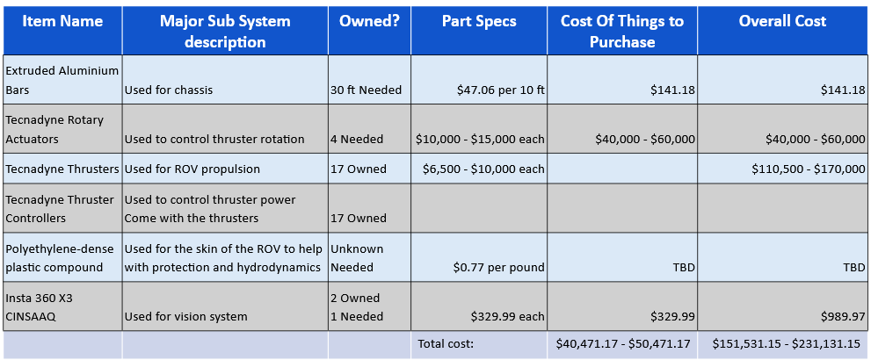

# 

# Glossary

Terms and acronyms that are associated with your project. If it is an engineering measure (specification), provide units.

* Propwash: The effect that thrusters have on the fluids passing through them. This effect makes the fluids rotate in a spiral pattern after passing through the propeller.
* Tether (Umbilical): The wired connection between the ROV and the pilot on the surface which powers the ROV and controls the thruster directions and powers.

# -Introduction

State the general need for what the inspiration was. Try to present it from the client’s perspective.

Then summarize the design approach used as entailed in this report.

**NOTE: Use of *qualitative statements, especially in the analysis section,* must be kept to a minimum (5 to 10). Overuse of qualitative statements in a section, or sections, will lower the grade in that section by ½ to 1 letter grade for that section**

For example, “The heat dissipation was lowered significantly by reducing the ohms of the series pass resistor”. Compare this to “the heat dissipation was reduced from 3.0 Watts to 1.6 Watts by changing the series pass resistor from 0.3 ohms to 0.16 ohms”. The adjective “significantly” just makes the reader ask questions. A mechanical example: “The temperature was lowered a lot by increasing the area of the fins”. This should be written, “The steady state temperature reduced from 153F to 141F when the area of the fins increased from 45 in2 to 63.4 in2.”

The inspiration for this project was to innovate in the current industry of Subsea ROVs. Our client considers them bulky, unmaneuverable, and somewhat inelegant in their design. They wish to challenge the norms of the industry by creating a rover that is incredibly intuitive to control, and with a wider variety of movement and vision.

The inspiration behind this project is derived from our client’s vision to revolutionize and innovate within the SubSEA ROV industry. Our client perceives current ROVs as bulky, difficult to maneuver, and lacking elegance in their design. Our client seeks to challenge these industry norms by creating a new and unique ROV design.

Their goal is to create a rover that is incredibly intuitive to control, offers a wider range of vision, and has enhanced maneuverability, much like a diver would have. Ultimately, the inspiration for this project was offering alternatives to both divers and ROVs, transforming how industries can choose to operate underwater.  
  
Our client was looking towards diver-like movement, which entails 6 degrees of freedom of movement, meaning the rover can move underwater like a diver. Our client also wishes for our rover to have 360-degree vision, in several axes, for enhanced situational awareness that will lead to more efficient task completion.

**Design Identification and Definition**

## -Need Statement and Analysis

Now that you have some experience and depth of knowledge of the project and if your team is not comfortable with your original Need Statement, now is the time to make it better. When well written, this is a very good way to let your reader know your thought process. Don’t worry about describing the development of it (i.e. the iterative development of it). Should the team feel that the history is needed, it can be provided in the appendix. Be sure to let the reader know. Simply state what it is, and then analyze it (identify key terms/phrases or performance measures). If your team has multiple elements to examine, present a need statement and analysis for each element. Be sure to clearly identify what the need statement relates to. The need statement should have a one to two sentence lead in, shown as an italicized statement with a follow up statement that leads to the need analysis. The need analysis needs to expand on key words and provide insight to potential means of measuring performance.

Design the chassis and propulsion systems for a subsea ROV, that can be used to replace human divers and fit into tight areas than current models, with consideration of buoyancy, versatile visibility interfacing, and 6 degree of freedom maneuverability.

The subsea ROV project was split up into a 5-year plan. The first year worked on the administrative side of the project figuring out how the ROV should be spaced out throughout the five years and working on the main goal of the project. The second year worked on the vision system, including full 360 degree viewing and a borescope for additional viewpoints. We are in the third year of this project. Our tasks are the chassis system and the propulsion system, which is why the need statement only concerns itself with the chassis and the propulsion subsystems of the ROV.

The ROV will need to have either a positive, neutral, or negative buoyancy, which has been left up to the team to decide during the creation of the chassis and propulsion systems. While the team is not focusing on the vision subsystem of the ROV, the chassis and vision subsystems work together. The chassis must be designed in such a way that it gives the vision system the full 360 degree view that has been worked on. Because the team is working to make the ROV more diver-like, the propulsion system must be able to accommodate for the full 6 degrees of freedom, as human divers are able to move in all translational directions and rotations.

## -Quality Functional Diagram (QFD)

Provide an opening paragraph explaining the goal of the QFD (i.e. tie into the Need statement and need analysis and client). Then present the QFD. Should it be too big, break the rooms up and present them individually. This should provide a bridge from the needs to the functions and specifications. Rooms 2, 5, 6, 7 and 8 are probably the most critical rooms to address. Should rooms be limited in information, briefly explain why that might be. The QFD is the go to reference for other areas of this report

The goal of the Quality Function Diagram is to take the clients needs and logically apply them into specific design and engineering requirements for our project. By looking at and comparing the statements, need analysis and functions, the QFD allows us to prioritize subsystems, and address what features correlate with each other, along with comparing it with some features of the competition. Some of the ideas we were looking to address pertain to the ROV’s size, maneuverability, and overall thruster pattern.



**Figure 1.** Chassis subsystem House of Quality



**Figure 2.** Propulsion subsystem House of Quality

The QFD starts with room 2, which addresses the needs of the clients. For the chassis, some of the most notable ones are the 360 FOV, and accommodating the thrusters. For propulsion some of the notable factors are having 6 degrees of freedom, and variable thrust. These factors guide the functions that our design should have.

Room 5 addresses the engineering specifications for each subsystem. Some of the notable engineering specifications for the chassis subsystem are depth resistant to 10,000 feet and allow for 360 degree field of view for the vision subsystem. For the propulsion subsystem, some of the notable engineering specifications include being stable in 2+ knots of current and having accurate propulsion for accurate movement.

Room number 6, the large center room, describes the relationship matrix, it describes the relationship between the engineering specifications and the customer requirements. Some of the notable relationships between the customer requirements and the engineering specifications are how the budget has a large relationship with every engineering specification in the propulsion subsystem, because the thrusters and rotary actuators that have been donated or researched are expensive.

Room 7, the block on the bottom, describes the engineering requirements, it utilizes the middle section, and sums and normalizes the relationship matrix in order to determine the percentage importance of various engineering specifications with respect to the importance of the customer requirements. For the chassis subsystem, the most important engineering specifications were being depth resistant to 10,000 feet and maneuverable. For the propulsion subsystem, the most important engineering specifications were accurate vehicle acceleration and reliability.

Room 8, the triangle at the top, shows how each engineering specification correlates to each other. One of the strongest propulsion correlations are controllability and vehicle accelerations, with the chassis correlating tether management and maneuverability, along with depth and water resistance.

## 

## -Background and Design Research

Present a summary of research the team conducted to gain a better understanding of the current state of technology on the design challenge. Try to keep to two pages. Potentially, could summarize activity in a table(s) {one table for patent search, one table for general web search, etc}. Including when the research was conducted should map into the design process. That is, early research might be very general whereas later research on analysis is more specific. A more detailed research listing would go into the Appendix B section.

Some of the research the team conducted in order to gain a better understanding of the technology was by looking at the current thrusters we had been provided with by the previous team. We found the specifications and the CAD models that were necessary in order to find the dimensional components to create our design. The team also researched the other electronic components that were obtained by the previous years, such as the Insta360 camera, borescope, and the Meta headset that was used for the VR display, to determine the best methods for mounting the cameras and the borescope onto the ROV for 360 degree field of view.

The team also spoke with Oceaneering International, Inc. to gain a better understanding on the current state of the industry. The talk addressed various issues such as the material selection, maximum payload capacity,, thruster placement specifics, and underwater conditions during subsea work, such as currents and buoyancy. During the presentation, Oceaneering gave insight as to how their current ROVs are able to perform underwater and the process the teams at Oceaneering took to design their ROVs. Oceaneering International gave a better idea on determining what market the team should compete in.

**Table 1** and **Table 2**, below, show the US Patents and US and international Codes, respectively, that the team researched to develop potential designs for the final product. The patent US 20240101236 A1 is for a modular subsea remotely operated vehicle with one section of the ROV that can connect to another section to increase the capabilities of the ROV. The code API RP 17H discusses how connections and interfaces in subsea engineering should be built so ROVs across companies can interface with the valves and connections underwater.

**Table 1.** Researched Patents and Trademarks

| **Patent Document ID** | **Patent Holder** | **Publication Date** | **Patent Name** |
| --- | --- | --- | --- |
| US 20240101236 A1 | Oceaneering International, Inc. | 2024-03-28 | MODULAR SUBSEA VEHICLE |
| US 20240383591 A1 | Heliopolis Holdings Limited | 2024-11-21 | UNDERWATER DOCKING STATION |
| US 20240239457 A1 | Taylor; Shawn  Cutri; Alex  Nguyen; Khang  Yousif; Sarmad  Le; Thanh | 2024-07-18 | AN UNDERWATER PROBE OR SUBMERSIBLE |
| US 20240218761 A1 | TLA SUBSEA LTD | 2024-07-04 | APPARATUS, SYSTEM AND METHOD FOR TETHERING A SUBSEA ASSEMBLY |

**Table 2.** Researched Standards, Codes, and Regulations

| **Code ID** | **Code Name** |
| --- | --- |
| IMCA D014 | IMCA international code of practice for offshore diving |
| IMCA D049 | Code of practice for the use of high pressure jetting equipment by divers |
| IMCA D045/R015 | Code of practice for the safe use of electricity under water |
| IMCA R004 | The safe and efficient operation of remotely operated vehicles |
| IMCA D054/R020 | Remotely operated vehicle intervention during diving operations |
| IMCA R009 | ROV mobilisation |
| API RP 17A | Design and Operation of Subsea Production Systems |
| API RP 17H | Remotely Operated Tools and Interfaces on Subsea Production Systems |
| API RP 17P | Recommended Practice for Subsea Structures and Manifolds |
| API RP 17V | Recommended Practice for Analysis, Design, Installation, and Testing of Safety Systems for Subsea Applications |

## -Function Structure

Provide a brief explanation as to what this section presents. Also provide an explanation as to what **FR (function requirement), PR (performance requirement),** and **CR (constraint requirement)** represent. The level of the function structure doesn’t need to go more than three levels (more detailed levels can be presented in appendix if needed) for any top-level function. Your original and more complete function diagram is to be included in the appendix. The primary focus here is to establish what the concepts/alternatives need to do and help define any performance requirements as well as constraints.

Note: There are a couple of different ways to present this information. One is a bullet list, or function tree, as shown below. The other is a diagram (as shown in lectures).

**Function Tree: (example, can be put into table form or other).**

**FR 1.0** *function description (remember, this must be an action)*

**PR1.0** *Associated performance requirement(s)*

**CR 1.0** *Associated constraint requirement(s)*

**FR 2.0**

**FR2.1**

**PR 2.1**

**CR 2.1**

The function structure describes the functions that the design (not the design team) must accomplish to meet the need. It guides the entire project. The function structure may be presented in organization chart format or outline format as pointed out earlier. The organization chart is usually easier for people to follow, but the challenge is making sure it is readable. Organization chart format is illustrated in the following. The top box contains the need statement with the functions broken down into subsections as shown below. Performance requirements and constraint requirements are identified. More information on these are in the next section. The function tree as shown above, is a little harder to follow sometimes, but is easier to read. The organizational chart, flow diagram, can be broken up into subcomponents and presented if it helps.

Our diagram is primarily split into 2 parts: the chassis and propulsion systems we will be designing for the ROV. The chassis objectives are highlighted by a need to create a shape that allows the vehicle to act as much like a human diver as possible, reflected by top-level criteria of small size and tooling accommodations. The propulsion system is meant to be complimentary to the chassis’ humanlike scale and shape. The operator should be able to manuever the ROV with a mindset similar to that of them being submerged themself. The propulsion system will also be responsible for keeping the ROV stable during tasks, managing changes in mass or environmental factors such as underwater currents.



**Figure 3.** Primary Function Structure

Design Specifications Table

Provide an introductory paragraph explaining what this section and table represent. This needs to map back to the previous section as well as back to the QFD.

Table I, summarizes the design requirements and specifications for this project.

*Note:This page is in portrait setting. Explain how the content of the table on the next page was developed. Keep the table on the next page in landscape settings.*

Our design specifications table revolves around the two primary functions of the 2024-2025 subsea ROV development phase: chassis and propulsion system development. This table is a representation of the high-level design requirements, and goes into more detail about the lower-level needs that will be met in order to successfully meet the requirements of the need statement. The chassis design will be done with a couple key elements in mind. The functions of current industry-standard light-duty ROVs must be maintained if not improved. This includes structural design that effectively holds necessary components such as electronics and tooling, as well as a manipulator and camera system. A smaller chassis that features the ability to see more in the likes of a human diver allows more information to be collected and difficult spaces to be accessed, keeping divers out of danger and more efficiently completing tasks. The propulsion system is designed to further reflect the ROV’s human-like properties. The mounted thrusters will provide motion in any direction, and the theoretically ability to orient in any way (full inversion may not be realistically necessary).

*Note: a “section break” was used to allow the table to appear in landscape mode. Be careful deleting lines.*

**Table 3.** Design Requirements and Specifications

| Function | Action | Parameter/ Constraints | Analysis Type  (Engineering Science) | Comments |
| --- | --- | --- | --- | --- |
| 1.0 | Develop unique chassis | Reduce size to access tight spots | Structural Analysis, CAD design, fluid dynamics, budgeting | Keep material selection in mind. |
| 1.1 | Accommodate a previously designed visibility system | 360 degree, <100ms latency | Electronics interfacing, energy management, data rate, processor speed | Focus more on visibility, and its respect to physical systems. |
| 1.2 | Utilize tooling and a manipulator | Receive accessories, operator-friendly interfacing | CAD modeling, material analysis, | Research standardized tools and tasks, and keep mounting consideration in design |
| 1.3 | Utilize materials that provide strength and structure | Maintain positive buoyancy and remain strong at depth | Materials analysis, fabrication, | Should withstand 10,000 ft of depth |
| 2.0 | Equip chassis with efficient propulsion system | Provide 6 degrees of freedom | CAD design, fluid dynamics, Electronics, Energy management | It should be able to move in each direction independently. |
| 2.1 | Integrate 180 degree actuators | Mounted thrusters to rotate 360 degrees | Electronics, control systems, fluid dynamics | Ensure safety mechanisms to protect wiring. |
| 2.2 | Efficiently balance changes in mass | <0.1 second reaction to changes in load between 4 active thrusters | Fluid dynamics, motion control | Incorporate redundancy in case of thruster failure as well |
| 2.3 | Efficiently manage tether | Protect tether; prevent exploration inhibition | Electronics, control systems, fabrication, CAD modeling | Consider improving tether visibility through reflectors or colors. |

A brief paragraph or two discussing the main points is appropriate here. The analysis type must be included and need to be meaningful to the parameter. Analysis type should be more than say “heat transfer”. Be more descriptive..i.e. convective heat flow. Or, beam analysis based on deflection. The comments box can provide content such as level of confidence, constraint, or other indicator of level of understanding.

This project utilizes a wide interdisciplinary variety of analysis. Most of these types of analysis will require an accurate CAD model for proper analysis. Fluid dynamics of underwater propulsion systems and Finite Element Analysis will be necessary for optimizing the maneuverabilityof the ROV, along with deflection modeling for the structure and beans within the system. A small amount of analysis, most likely done by hand, is needed to analyze the visibility systems, but will also require an accurate CAD model. Physically budgeting our design is necessary to understand how the chassis and propulsion system will be able to accommodate each other, and be able to undergo scaling as the prototyping and building phases reveal necessary changes. Analyzing these systems through these various lenses, we will have a robust and comprehensive understanding of our design.

## 

## 

## -Overall Expected System Description

Provide insight as to what are the key attributes and/or features that the design needs to have. Okay to reference what your client has stated. Identify what are some of the key operational points as well. That is, lay the groundwork for the concept section.

Some of the key attributes for the chassis design are the ability to accommodate the thrusters, the electronic and mechanical components of the ROV, and the vision system. The chassis of the ROV must be able to mitigate the thruster prop wash that comes from thrusters. Propwash is the effect that thrusters have on the fluids passing through them. This effect tends to make the fluids rotate in a helical pattern after passing through the propeller. The helical rotation of the fluids decreases the efficiency of any thrusters that the fluid passes through. Because of this, the chassis must be able to mitigate propwash to keep the thrusters at their optimal efficiencies. The chassis must also be big enough to house the electronic and mechanical components of the ROV while keeping the overall weight of the chassis to a minimum. This means that every part should have a purpose and if the product can be designed with fewer parts while achieving the same outcome, the design with fewer parts should be chosen. One of the main goals of the previous year was to develop a way to have a 360 degree field of view. So while the objective of this team is not concerned with the vision subsystem, being able to incorporate the 360 degree field of view into the final design is an important attribute for the chassis design. Another aspect of the ROV chassis is that the current stage of the ROV design does not require it to be marinized. This step comes in one of the next years of the multi-year design process.

The key attributes for the propulsion system design are from the propulsion subsystem to be economical, have 6 degrees of freedom, and have the ability to resist underwater currents. For the propulsions system to be economical, it must have no unnecessary parts. As stated earlier, every part should have a purpose and the design with fewer parts while having the same outcome should be selected. This will reduce the weight of the ROV and reduce the number of potential failures. Divers underwater are able to swim and rotate in all directions. Meaning if an ROV is to be designed with diver-like capabilities, it must also be able to move and rotate in all directions. Divers are unable to work properly in 2 or more knots of current. For an ROV to be more capable than divers, the ROV must be able to withstand greater currents than divers are able to.

# -Concept Generation and Analysis:

Summarize the process that the team conducted to reach the final concept. This is an abbreviated version of what is in the concept report.

When introducing the problem to the team, the sponsor gave examples of current ROVs, such as the Oceaneering Isurus and Magnum, both of which are cuboid in shape, as well as several abnormally shaped ROVs. The team looked into these abnormally shaped ROVs to determine if there was a possibility of making our ROV unusually shaped.

Our first design, nicknamed The Death Star, shown below in **Figure 4**, was a spherical ROV with thrusters and cameras surrounding the outer shell to give the full 360 degree field of view and 6 degrees of freedom. While this design had some of the more important customer requirements from the QFD, The Death Star had little room for an arm to interact with things underwater. The design was also significantly heavy for its size as it used six thrusters and therefore was very slow in its movement.



**Figure 4.** The “Death Star” design

Our second design, The Box, shown below in **Figure 5**, was similar in shape to the Oceaneering Magnum, but much smaller. This design was able to give us the full 6 degrees of freedom needed, but had some blind spots in the field of view. This design was also not able to fit into the small gaps required of it by the sponsor.



**Figure 5.** The “Box” design

Our final design, The Turkey, shown below in **Figure 6**, was shaped like a coffin or turkey. This design gave us 6 degrees of freedom with 4 thrusters, making it much lighter than The Death Star and much smaller than The Box. The design was also able to have 360 degrees of view. The previous team who worked on this project worked on the vision system, and they found that a coffin shaped chassis, similar to our design, gave the best design for 360 degree vision.



**Figure 6.** The “Turkey” design

With these designs and their capabilities, we created a decision matrix to compare the designs with the customer requirements and engineering specifications. Based on this decision matrix, shown below in **Table 4**, we chose to move forward with The Turkey design as we found it covered all of the important aspects as required by the customer and most of the functions we specified for the subsea ROV.

**Table 4.** Our Decision Matrix for each design



# -Design Embodiment

This section maps out how the team went from a general concept and started to identify specific components, or the specs for specific components. This section needs to tie function, parameters, and engineering specifications. This section needs to tie back to the function structure and design specifications sections.

Present the selected concept and identify all the major subsystems that make up the system.

Present a WBS of what needs to be addressed as design moves forward. This will essentially address

* Function/need of each sub-system and performance requirements.
* Configuration CAD drawing of system showing the relative location and size of major system components.
* FMEA/FTD: Address the failures of the top level systems and provide a FTD. The FTD demonstration can be of a single subsystem.
* Cost estimation of parts
* Any activity or area of the design that needs to be worked on.

The above should be reflected in tables that teams were to work on in Week 10 through Week 12.

## -System Description

Present the system that the team is moving forward with and all of the major subsystems and their relations to each other. CAD drawings are needed. First two bullet points from above. Should developing CAD models prove difficult, neat sketch drawings with details could be an option. Goal is to provide the audience with a pictorial reference of the design and the components. Any figure used needs labels identifying the major components and key features/attributes.

The system that the team is moving forward with is The Turkey design. This design has the ability to move in all 6 degrees of freedom with 4 thrusters. Because scalability was an important aspect for the final design, the amount of thrusters can be doubled to increase the amount of force on the ROV when the 4 original thrusters aren’t enough for the weight of the expanded ROV. The previous team worked on the vision system, and to maintain a 360 degree field of view, the previous team determined that a coffin shaped chassis allowed 360 degree view with the fewest number of cameras. The Turkey design that the team came up with is similar to the coffin shape that the previous team designed, which allows The Turkey design to also have the 360 degree field of view that the customer required. With the tether connection at the back of the ROV in The Turkey design, the ROV is able to maintain control of the tether by keeping some tension in the tether. This keeps the tether away from the thrusters which could destroy both the tether and the thrusters. With the protective skin and the domed roof, The Turkey design is able to both contain and protect the electrical and mechanical components inside the ROV, while providing the floatation that is needed to keep the ROV at a neutral buoyancy. The final design of the ROV is also small in stature, at 25 inches wide, which allows the ROV to be able to fit into the tight places that a diver could fit into. However, the scalability of The Turkey design allows the ROV to be larger if a need requires it to be stronger and have a larger payload capacity rather than being able to fit in narrow spaces.

Seventeen Tecnadyne Model 300 thrusters were donated to the team, of which The Turkey design used four thrusters. Tecnadyne gave the team the CAD models for these thrusters, along with the CAD models for the Tecnadyne Model 20WD rotary actuators that were selected to be used in the concept generation phase. Extruded aluminum bars will be used as the basis for the frame of the chassis because it is corrosive resistant and cheap. With polyethylene-dense plastics being used for the protective skin, because it is strong against impacts, water resistant, and cheap. Because the current stage of the ROV is a proof of concept stage, the final materials used as the frame of the chassis and the protective skin might be different from the current materials.

**Figures 7** and **8** below show the isometric drawing and the CAD model of The Turkey ROV. The figures show the ROV at its smallest scale, by increasing the length and size of the bars, the size of the ROV can be increased to make it stronger against currents, faster, and have more capabilities like those of larger ROVs, such as the Oceaneering Isurus.



**Figure 7.** Isometric drawing of The Turkey design. The design will be 24 inches long, 25 inches wide, and 10 inches tall.



**Figure 8.** The CAD drawing with the Tecnadyne Model 300 thrusters and Tecnadyne Model 20WD rotary actuators labeled.

## -Human Factor Engineering

Present initial considerations on how people will be expected to engage with the design and initial areas that will be developed further.

The main control interface for the ROV is expected to be a VR system that incorporates a full 360 degree view from all the cameras. The design of this, however, is designated for future work. As for the chassis design, the camera mounting points must be carefully considered in order to successfully achieve that full 360 degree vision.

The size and shape of the ROV must be designed for humans to store and house. If the design is small enough, lifting points for human technicians must be considered and implemented on the chassis. If it is larger than can reasonably be carried by a team of humans, consideration must be given to how it will be lifted by crane and how the attachment to said crane works.

## -Engineering Analysis

Provide a summary as to how the team identified areas that need analysis as well as how the team categorized the types of analysis. The goal is to present areas that the team will be working on or address next term. Team does have to show at least two areas of analysis, even if well constructed OOM calculations are a start.

* Analysis, and identification of areas that require analysis
  + Major analysis: Areas that will require application of CAE tools (identify what is to be used).
  + Parametric analysis: Areas where there are multiple parameters that can be changed that can impact design performance.
  + Need to have some OOM (order of magnitude calculations) to present. Need to explicitly address what engineering analysis/science apply, assumptions. Hand calculations can be put into the appendix.

There are several areas that will require engineering analysis.

* Force and torque calculations are necessary to make sure that our design indeed provides all 6 degrees of freedom to the ROV. We have verified the three translational directions with some rough order of magnitude calculations, showing that there exists at least one angle (45 degrees) where strafing is not only possible, but equal in force magnitude to forward motion. However, some of that analysis involves the reactions of the thrusters to the backwash of the other thrusters, meaning that there must be:
* Fluid simulation for our ROV, showing how hydrodynamic the overall design is, what the effects of thruster backwash are, what the effect of the shape is on our speed, and whether or not it can withstand currents up to 2 knots.
* Loading analysis on the chassis frame, showing how much pressure is exerted both by the water and payload in order to make sure that the material selection is correct
* Order of magnitude calculations were run for the cost of the thrusters and rotary actuators. The torque output of the rotary actuators was estimated to determine if there would be enough force to turn the thrusters, and the output force of the thrusters was estimated to determine the overall speed and acceleration of the ROV while underwater.

## 

## -Failure Mode and Effect Analysis

Provide a top level and first run analysis as where possible concerns exist in the design that could impact the design to successfully complete its intended functions. Include a FTD as well. Goal is to demonstrate that the team has identified failures that could impact the ability of the design to not perform their intended functions. Identifying means to potentially mitigate them is desirable.

**Table 5.** The Risk Priority Number calculations for our Failure Mode and Effect Analysis



## -Cost Estimation

Cost estimation and/or bill of materials goes here. Provide an estimated cost even if a majority of the resources are being donated. Can create one column showing estimated cost and a second column identifying if the part/component is donated or not. The table can show the cost per subsystem. The detailed cost of the subsystems can go into the appendix. Worth addressing “high” dollar cost vs. “low” dollar cost. If a cost estimating tool is used, be sure to specify how it is used and the limitations.

## 

**Table 6.** The cost estimation for the project, including the cost for starting the project over without the items already obtained.



The final shape of the ROV has not yet been determined, so the amount of polyethylene-dense plastic is unknown.

## -Work Breakdown Structure Semester II

Two items will be addressed here. The first is the WBS identifying what all has to be done. The second is a tentative Gantt chart (work from 2nd/3rd week in January to first week in May).

Provide a projected schedule for next semester. Try and include what specific tasks that you expect to have to undertake. An outline form is acceptable. Some tasks might overlap with other tasks. A table broken down into a 14 week period for columns, with tasks identified in each row is acceptable. The table might be better suited for a landscape orientation.

**Figure 9**, below, shows the Work Breakdown Structure for the chassis and propulsion subsystems. The WBS is separated into three subsections, one for the chassis design, one for the propulsion design, and one for all administrative work such as budget planning and research.

The chassis section of the WBS is split further into a branch for mounting the components and for protecting the components. The sub-branch for mounting the components contains tasks such as designing how the control system electronics will be placed to maximize their efficiency and minimize their spatial footprint, designing how the cameras should be mounted to ensure 360 degree field of view, and designing how the tether should be mounted to prevent it from being damaged or disconnected during ROV motion. The sub-section for protecting the components includes tasks such as designing a chassis shape that will protect the components from fish and terrain and selecting materials that are strong enough to resist impacts and corrosion.

The propulsion section of the WBS is split into subsections that include the force and torque analysis of the propulsion system and determining the placement of the thrusters to allow for 6 degrees of freedom. During the brainstorming phase of the project, several designs were created for each of the chassis and propulsion systems. The designs were then integrated together to determine the best combination of the chassis subsystem and the propulsion subsystem that the final design of the ROV would be based on.

**Figure 10** shows the Gantt chart that was made using the WBS as a basis. The CAD design will be finished before the engineering analysis parts will begin, however the CAD design will be redesigned if any of the engineering analysis determines that the design is unable to meet the customer requirements and engineering specifications. While the CAD design and engineering analysis are being performed, the materials for the ROV will be chosen. Different materials have different mechanical properties, so the engineering analysis must be done with the materials that will be used in the final design. Once the engineering analysis is completed and the materials are chosen, the parts will be ordered and the fabrication process can begin.



**Figure 9.** The Work Breakdown Structure for the project



**Figure 10.** Gantt Chart for the spring 2025 semester

# -Summary

Summarize the work down for the semester. This section would be an expanded upon executive summary Convey the important aspects of the design and what is left to do to get a functional prototype that can be tested.

And as usual, thank your sponsors, etc.

Whenever divers work underwater, they put themselves at risk of injury and death. Because of this, divers are only able to safely work at about 100 meters, and most deepsea infrastructure is much deeper than that. There is a need to replace these divers to take them out of the risky scenarios while maintaining the capabilities of a human diver. The current models of subsea ROVs are big, expensive, and unmaneuverable. To make an ROV similar to that of a human diver, it must be smaller, able to fit in the same size holes and areas that a diver can, and be able to swim like a diver could underwater.

The final design decided upon was shaped like a turkey, with four thrusters equipped with 360 degree rotation and a chassis shaped like a coffin, which allows for camera placement in line with previous work as well as defined interfaces for the manipulator arm and tether.

To create a functional prototype, the engineering analysis must still be finished, the final parameters of the design decided upon, the materials sourced and acquired, and the prototype built and tested.

A special thanks goes to Mr. William Ledbetter and Mr. Don Wells for their generous support in helping the team with their work in working on the project. Thanks also must be given to the members of Oceaneering International, Inc. for their willingness to talk with the team about subsea ROVs and their experiences in the industry.

# Appendix

*Delete this note: If there is not an entry, provide a brief explanation as to the lack of entry.*

## A. List of Abbreviations

* API RP - American Petroleum Institute Recommended Practice
* CAD - Computer Aided Design
* FMEA - Failure Mode and Effects Analysis
* QFD - Quality Function Diagram
* ROV - Remotely Operated Vehicle
* USPTO - United States Patent and Trademark
* VR - Virtual Reality
* WBS - Work Breakdown Structure

## B. References

Put in your literature search – take credit for it. Citing will follow the format for ASME journal publications. (<https://www.asme.org/publications-submissions/journals/information-for-authors/journal-guidelines/references>)

### **CODES**

IMCA D014 IMCA international code of practice for offshore diving

<https://www.imca-int.com/resources/technical-library/?sourceID=134b165f-c55b-ee11-8def-6045bdd2c9bc>

IMCA D049 Code of practice for the use of high pressure jetting equipment by divers

<https://www.imca-int.com/resources/technical-library/?sourceID=96325a5b-c55b-ee11-8def-6045bdc208e3>

IMCA D045/R015 Code of practice for the safe use of electricity under water

<https://www.imca-int.com/resources/technical-library/?sourceID=9316b95b-c55b-ee11-8def-6045bdd2cf5f>

IMCA R004 The safe and efficient operation of remotely operated vehicles

<https://www.imca-int.com/resources/technical-library/?sourceID=60d8d35a-c55b-ee11-8def-6045bdd2c0c0>

IMCA D054/R020 Remotely operated vehicle intervention during diving operations

<https://www.imca-int.com/resources/technical-library/?sourceID=035bc45a-c55b-ee11-8def-6045bdd2c3b2>

IMCA R009 ROV mobilisation (sic.)

<https://www.imca-int.com/resources/technical-library/?sourceID=04883c5f-c55b-ee11-8dee-6045bdd0ef45>

API RP 17H Remotely Operated Tools and Interfaces on Subsea Production Systems

<https://standards.globalspec.com/std/13385742/api-rp-17h>

### **PATENTS**

## C. Order of Magnitude and Detailed Calculations/Analysis

Put in your work – again, take credit for it. Work here needs to be unambiguous and clearly identifiable as to how it pertains to the development of the work down by the division.

## D. Concepts Entertained



**Figure 4.** The “Death Star” design



**Figure 5.** The “Box” design



**Figure 6.** The “Turkey” design

## E. Down Select

## F. Detailed working drawings/models/assembly

## G: Cost Estimation Details

**Table G.1.** This table shows the cost estimation of the prototype for the ROV for next semester, including donated parts and as-of-yet unobtained parts.



**Report Format:**

1. **Font: Times New Roman 11 point.**
2. **Line spacing: 1.15**
3. **Fully justified**
4. **Margins: Left: 1. in, Right: 1.1 in, Top: 1 in. Bottom: 1 in.**
5. **Tense: 3rd person, past tense.**
6. **English (US spellings).**
7. **Figures: Must be captioned at the bottom, referred to in text, and be placed as close as possible after reference. No smaller than 2.75x2.75 in (65x65mm). Centered on page. Multiple figures could be placed on one page, but no more than 3 to a page. Text in figure cannot be smaller than 8pt. If inserted in landscape, i.e. for large figures, image must be viewable from the right hand margin. Must stay within margins.**
8. **Graphs: axis must be labeled (font no less than 10 pt), multiple curves on one graph must be distinguishable in terms of line type (don’t rely on color to distinguish curve). Captioned as a figure. If inserted in landscape, must be viewable from the right-hand margin. Font within graph cannot be smaller than 8 pt. Avoid cyan, yellow, pinks, light green, etc for line colors. Title on graph is not necessary as caption will state title. Must stay within margins.**
9. **Tables: Must be captioned at the top, centered on page. Font in table cannot be smaller than 9pt.. If inserted in landscape, must be viewable from the right-hand margin. Must stay within margins**
10. **Equations: Must use MathType or Word equation editor for main body of report. No scanned or copied equations. Equations must be numbered, variables defined, and units presented. Must stay within margins. Handwritten work (neat and commented) can be put into appendix.**
11. **References: Refer to the standard format for referencing as set by the ASME journals.**
12. **Appendix: This is a catchall for the important work that may need to be referenced later, design details. This area has some freedom as far as formatting: all landscape images must be viewable from the right hand margin, all content must fit within margins. Any handwritten work must be clear and complete. Analysis should include comment statements and explanations as to the steps taken in the analysis, assumptions made, significance of results. Computational work done using any code requires a statement of assumptions, limitations of analysis, and meaning of output.**
13. **Drawings/models: drawings need to be a drawing block, dimensions need to be provided, title needs to be included as well. Again, if inserted in landscape, must be viewable from the right-hand margin. Any text in drawing must be readable (no smaller than 2 mm). If there is a larger drawing that is on larger paper, it can be inserted as a fold out. As an exception to the margins, these can have a 1” margin all around. Note that the left hand is space for binding the report.**